Northwest Integrators LLC, Stamford, CT Aug 2001-Mar 2002
Business Analyst
Northwest Integrators LLC is a global leader in delivering investment management, asset and fund administration, fiduciary and banking solutions to corporations, institutions and individuals. The project was to implement a comprehensive trading system for asset management business. The system handles the trading of equity, fixed income and derivative for listed and OTC market. It enables its users to simultaneously trade a comprehensive set of securities, track live P&L values and examine exposure to shifting market prices, interest rates, volatility, yield-curve assumptions and other risks.
Responsibilities:
- Strong Financial Domain knowledge in Fixed Income (CDs, Treasuries, MBS, ABS, Corporate Bonds, Municipal Bonds, and Preferred Stock), Equity Securities, Derivatives (Options including Warrants, Call and put; and Futures)
- Conduct analysis on Trading Lifecycle in front office to back office systems and documented with diagrams.
- Solid experience in fixed income trading with estimation of Coupon Rate, Current Yield, and YTM.
- Performed Fixed Income Analysis (Pricing, Risk, Yield, Duration, And Recommended Strategy) with Excel to support trading, and reviewed with portfolio manager and traders.
- Assisted Risk Management Group in financial and Risk analysis on calculation of PV, and other key trade metrics (e.g. Breakeven Rate)
- Gathered business requirements from traders, portfolio managers, hedge fund managers, and risk management group to identify and map detailed current processes and develop functional requirements that supported overall strategy, goals and objectives, and develop and document the BRD and FSD.
- Worked with developers to develop and document technical specifications of system document.
- Prepared Data Administration department's charter document, which included definition of roles and responsibilities for IT technical positions, data management standards, data architecture principles and practices.
- Designed the logical and physical databases, and defined the ETL rules, for a multi-terabyte customer relationship management data warehouse.
- Acted as liaison between management and development team for Requirements and QA testing during the User Acceptance Testing (UAT) phase and involved in user interfaces, requirements and data modeling sessions.
Environment: UML, RUP, Rational Rose, Rational Requisite Pro, MS Office (MS Word, MS Excel, MS PowerPoint, MS Visio,), Visual Basic, Cognos Report, Quality Center, Windows 2000, Java, J2EE, Oracle 9i.

Tell me about this project?

Northwest is a mini investment bank.

This project was to set up a comprehensive application that deals with trade cycle of different equities, futures, and options. It also deals with coupon rates, yield to maturity (YTM: If you buy a bond, say, you get a coupon rate of $50, thereafter, you also get the future value of the bond. So, you calculate the total return you get during your holding of this bond: This is called YTM), etc.. So, this project basically dealt with from trade capture and middle office activities till the trade settlement (from clearing house to customers)

Who were the users of your application?
Customers like every day customers like Raman Kumar and Alok Bhatia, office staff (of Northwest) and clearing houses (guarantor of this trade)

What do you mean by “Designed the logical and physical databases, and defined the ETL rules, for a multi-terabyte customer relationship management data warehouse”?
Excellent article on: http://www.developer.com/tech/article.php/641521/Logical-Versus-Physical-Database-Modeling.htm

Logical database modeling: Figuring out the various data structures that we will need in our database. This is achieved through ER Modeling. We figure out the various entities, their attributes and the relationships between various entities: This is called Logical database modeling! Of-course, the needs of the business play a major part in logical modeling.

Physical database modeling: Physical modeling involves the actual design of a database according to the requirements that were established during logical modeling. When physical modeling occurs, objects are being defined at the schema level. A schema is a group of related objects in a database. A database design effort is normally associated with one schema. During physical modeling, objects such as tables and columns are created based on entities and attributes that were defined during logical modeling. Constraints are also defined, including primary keys, foreign keys, other unique keys, and check constraints. Views can be created from database tables to summarize data or to simply provide the user with another perspective of certain data. Other objects such as indexes and snapshots can also be defined during physical modeling. Physical modeling is when all the pieces come together to complete the process of defining a database for a business.

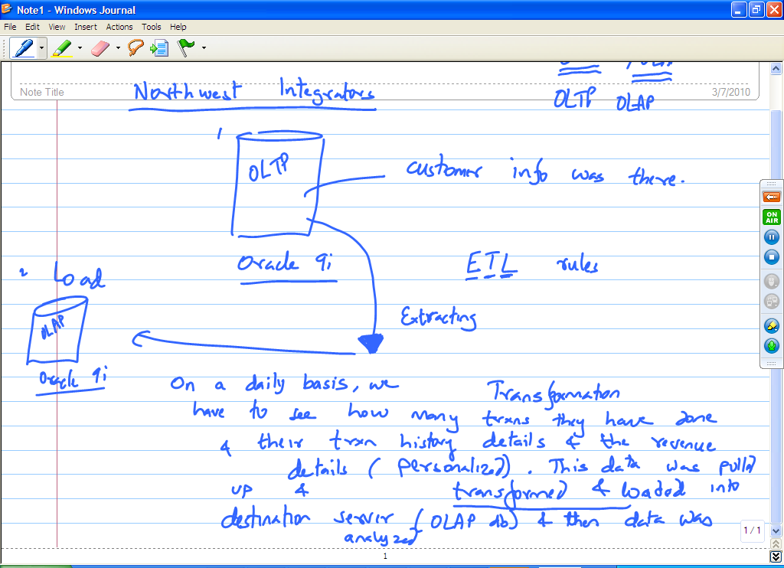

What kind of analysis did you do on the data in the system?
Customers on daily basis getting through our system, their loyalty, their revenues?

What is the reason to have a separate database for analysis (The reason to have an OLAP database when you already have an OLTP database?)
The reason for this is that it is not a good idea to do analysis on a database that is the main database of transactions which drives our business. An OLTP database (the main transactional database for a business) should not be used for analysis because analysis on a database slows down the database. Any queries that the data warehouse team does, competes with the real world transactions that the database is also trying to deal with from customers. That is the reason, that we used Informatica as our ETL tool to take the transactional data and put it in a separate multi-terabyte database (which also happened to be an Oracle 9i database).

What ETL Rules did you define?
Some of the ETL rules I defined using Informatica Power Center:

- While loading data from OLTP to OLAP database, convert states into geographical groupings. Senior management wanted to get reports on how are the various regions of USA doing as opposed to reports on individual states. So, I documented a transformation rule that grouped states like AZ, CA, WA, OR, NV, ID, UT into geographical region “WEST”. Similarly, states like LA, TX, MS, AL were grouped into geographical region “SOUTH”.
- Another transformation rule I defined was “Drop all the customers while loading data from OLTP to OLAP who have less than $10,000 in assets with us”.

